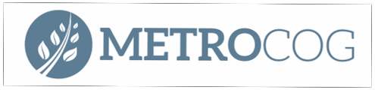

Conservation Technical Advisory Committee
Regular Meeting: Monday, December 9th, 11 AM
Meeting Link:
https://us06web.zoom.us/j/86899490877
Meeting Agenda:

- Welcome and Introductions

- Regional Updates

  - Regional Plan of Conservation and Development
  - Sustainable CT 2025 Fellow
  - Other Summer Intern Programs

- Legislative Updates

- Other Business-

  - Upcoming Opportunities
  - Urban Bird Treaty Updates

6. Adjourn

MetroCOG is inviting you to a scheduled Zoom meeting.
Topic: CTAC Quarterly
https://us06web.zoom.us/j/88975810728

